Date: October 18, 2021

To: McCullough Research Clients

From: Robert McCullough

Berne Martin Howard

Jean-Carl Ende

Anthony Nacrelli

Subject: The NERC/FERC Review of ERCOT’s February Rolling Blackouts

Last year North America experienced a great deal of extreme weather. It is clear that there are going to be even more extreme weather events – increasingly so with global climate change. That we are unprepared is not news – Hurricane Ida put a million customers out of power across eight states. Wildfires along the west coast have decimated whole towns and imperiled the grid. A single cold snap in Texas cost hundreds of lives. What is news is that we haven’t started preparing to get prepared for 2022.

Our society’s approach to preparing for climate change, if we had one, could best be compared to former President Trump’s many thoughtless pronouncements on the looming threat of Covid-19 in the spring of 2020. This is harsh – very harsh – but our economy, and possibly our lives, depends on understanding the actual risks that climate change presents to our energy infrastructure, and then preparing to address them.

A little background is appropriate on how we plan for and regulate reliability. Traditionally, electric utilities were responsible for reliability in their own service territories. The establishment of larger, integrated, electric grids has eroded local responsibility for reliability. On August 14, 2003, areas primarily under the administration of an independent system operator named PJM, experienced a widespread blackout. While the power was not out for long – seven hours – this was a wake-up call that the increasing interconnections posed a risk to larger and larger areas. Congress responded by passing the Energy Policy Act of 2005 on August 8, 2005. The Act assigned reliability issues to the Federal Energy Reliability Commission (FERC) who formally assigned them to the North American Electric Reliability Corporation (NERC) a year later.

The Energy Policy Act was a momentous change in NERC’s role. Before 2006, NERC was basically an industry association. After 2006, NERC became a legally sponsored regulator. Over the following fifteen years, however, NERC has gradually returned to its industry association roots.

Overall, NERC’s response to climate change has been surprisingly passive, and their documents offer little recognition of the scale of the challenge. For example, NERC’s 2021 Summer Reliability Assessment mentions the word “hurricane” but once – and only in the context of pandemic risks.[1] The summer assessment does a slightly better job on wildfires, but misses the critical reason these cause reliability problems in the west coast. In summer, the California Independent System Operator “leans” on resources in the Pacific Northwest. Unfortunately, the transmission lines between California and Oregon pass through potential wildfire areas and must be de-energized if a fire is nearby.[2]

The voluminous “Reliability Standards for the Bulk Electric System of North America” issued this summer weighs in at 1,951 pages mentions hurricanes but four times, and only in the context of a list of unlikely events.[3] Wildfires only justify two entries, again in the same context of unforeseen events.

The 2020 Long-Term Reliability Assessment from NERC does little better. Hurricanes are mentioned twice – both in the context of regional cooperation.[4] This is surprising given that at least six major storms made landfall on the Gulf Coast in 2020.[5] Wildfires were not mentioned at all. Cold weather was mentioned only in the context of New England.[6]

Understanding the changes that the global climate is undergoing clearly has not been on NERC’s radar in 2021. Last month, the Federal Energy Regulatory Commission and the North American Electric Reliability Corporation released their preliminary review of the cold snap that caused major electricity, natural gas, and water interruptions to Texas in February, entitled *February 2021 Cold Weather Grid Operations: Preliminary Findings and Recommendations*.[7]

For over 220 days 50 experts labored over the preliminary report of 32 slides – approximately 344 man-days per slide. The results are tentative and understated. Following the Category 4 Hurricane Ida by less than a month, a sense of urgency might have been expected. However, urgency was not one of the elements present in the report, even as a new winter season approaches.

The PowerPoint and its speaker notes, released on September 22, 2021, focus narrowly on cold weather and engineering, and comments very briefly on ERCOT policy issues such as underfrequency generator outages and protection of critical loads. The presentation makes nine key recommendations, plus five more for further study. Implementation of their recommendations “could extend beyond winter 2023-2024, but should be completed as soon as possible.”[8]

The PowerPoint also fails to consider the unique design of ERCOT’s markets where incentives reward failure far more than incentives reward success. In March of this year, Dr. Carl Pechman and Elliott J. Nethercutt issued a report addressing four issues in the ERCOT blackouts: “1) inherent market design flaws, 2) insufficient regulatory oversight, 3) market manipulation, and 4) the distinction between reliability and resilience in designing and managing the electric market.”[9]

The very preliminary review below provides some support for their analysis.

Elsewhere in North America, reliability is addressed outside of energy markets. The standard for the past hundred and some years is to set a reserve margin for the capacity on the system able to meet customer requirements in the vast majority of cases. Energy – the actual kilowatt-hours from the generators -- is charged at cost. The cost of capacity is also charged to customers – either at the cost of procurement or at market price.

ERCOT has eliminated the capacity market. Instead, the Texas PUC has set a price –$9,000/MWh – that is approached as reserve levels decrease, and in the case of February, was administratively imposed when rolling blackouts took place. This is roughly 300 times the normal price of electricity in most markets. This “surcharge for failure” approach is unique in the industry.

Imagine that the same approach was implemented in air travel. Almost all of the time, the passengers would purchase their ticket and enjoy their flight. When turbulence or equipment failure occurred – the dreaded moment when the pilot says “we will be diverting your flight to the nearest airport, but do not panic, all is under control” – he would also inform you, “the cost of your flight has just increased by three hundred times, and so has my salary.”

Although fanciful, the example faithfully summarizes the situation in ERCOT on February 15, 2021.

The surcharge for failure model may affect incentives in two ways:

1. Cold weather emergencies – including those that have occurred several times in recent years – are profitable for generators. In a traditional pricing model, failure to generate is penalized. In ERCOT, weatherization has traditionally been optional, but the pain for a cold snap is mitigated by the automatic price increase paid to the generators when it occurs.
2. When the $9,000/MWh price is mandated by ERCOT, there is an immediate incentive for generators to manage the shortage. The last thing a successful generator would want is the end of the emergency pricing. To avoid that, it might be tempting to remove generators from service in order to offset any rolling blackouts that had been ordered.

In February of this year, ERCOT experienced a massive dislocation in electric and natural gas supplies. Data from the period is still largely unavailable. However, some data is available on temperature in Texas, production of natural gas, generation outages, and rolling blackouts.[10],[11],[12],[13]

Causality – the identification of causes and results – often proves elusive. Obviously, a root cause was cold weather – erroneously identified as a “polar vortex” in the comments to the PowerPoint.[14]

The cold weather caused operating problems in the production and distribution of natural gas. It also created operating problems for electric generators. In response to a decline in frequency, ERCOT issued rolling blackout instructions to its transmission providers. The rolling blackouts contributed to outages in both the natural gas system and electric generators.

A simple diagram of the causal sequence in the February crisis is below:



The standard statistical technique for determining causality was pioneered by Professor Clive Granger in his pivotal Econometrica article in 1969.[15] Shorn of the mathematics, this approach asks the straightforward question “do opening umbrellas cause rain, or does rain cause umbrellas to open?” A careful researcher would watch to see which happens first – rain or umbrellas. And, the researcher would conclude that when it rains, we open our umbrellas. It is not our opening of umbrellas that caused the rain.

We have hourly data for temperature, natural gas production, generator outages, and rolling blackouts. The chart above reports the statistical significance of a one-hour causal relationship between the four major variables. In this case, the notation “99%” indicates that we are 99% confident in the significance of a Granger causal relationship.[16]

Professor Granger’s technique clearly indicates that falling temperatures “Granger Caused” a reduction in natural gas production and plant outages. When it comes to the relationship between rolling blackouts and natural gas production, it appears the blackouts “Granger Caused” a fall in natural gas production.

However, it also appears that the rolling blackouts may have “Granger Caused” an increase in generator outages where the plants are fueled by natural gas.

While the Granger Causality statistics provides guidance on the sequence of events in ERCOT, it doesn’t address whether the specific relationships are particularly critical. A very simple way of gauging the importance of the relationships is to report the R2 – the proportion of the variation in the dependent variable “explained” by the explanatory variable.

The R2 values for the relationships described above are:



*Blackout caused some Natural Gas Generation Outages

These R2 values suggest that the impact of low temperatures on natural gas production was not very strong. The relationship between falling temperatures and generation outages was even less powerful. However, the onset of rolling blackouts did seem to have a strong impact on both natural gas production and natural gas fueled generator outages.

Much has been reported on ERCOT and the Texas Railroad Commission’s inability to cooperate effectively and protect critical infrastructure from load shed during the emergency.[17] And as mentioned earlier, $9000/MWh provided an incentive for blackouts to be met with additional outages in order to extend the crisis.

Our results – particularly blackout’s ability to explain variations in generation outages, and declines in natural gas production – suggest that Dr. Carl Pechman and Elliott J. Nethercutt’s concerns about ERCOT’s market structure may have merit.

As we learned twenty years ago in California, bad policy can create the incentives for reduced reliability. The depth and severity of the Texas events in February 2021 makes this a concern to be investigated.

However, those entities most responsible for oversight, FERC and NERC’s joint staff “inquiry team”, did very little to investigate ERCOT’s idiosyncratic market and regulatory structures. Instead, they focused the majority of their attention on weatherization standards and a lack of interconnection to adjacent grids.

The inquiry team’s report begins by detailing a few summary statistics regarding the event’s magnitude, and offers a few summary slides on the role of cold weather and natural gas production declines in precipitating the crisis. They also correctly identified extreme cold weather as a persistent problem for energy reliability, and generation outages as the primary cause of the February emergencies.

However, by overestimating wind and solar outages when describing the generation failures by fuel type, the inquiry staff commits the same error as ERCOT in its *Preliminary Report on Outage Causes*, released April 6, 2021.[18] To their credit, on April 28, after we questioned ERCOT’s use of “nameplate capacity” rather than “expected production”, a correction of their initial report was issued.[19]

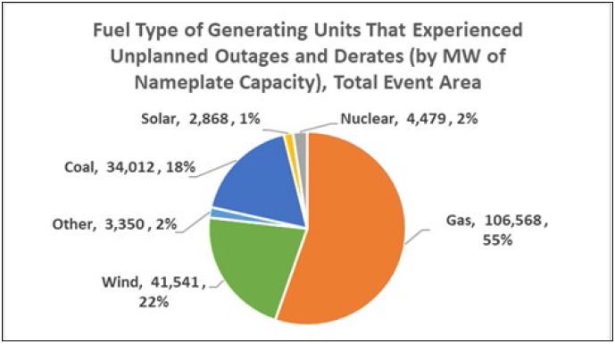[20]

The inquiry staff should have reported their outages on the basis of expected generation as opposed to nameplate capacity because intermittent renewables rarely generate at nameplate capacity. Given the public controversy surrounding the role of renewables in a reliable grid, the inquiry team’s report should have emphasized that using nameplate capacity unreasonably exaggerates the contribution of renewable generation.[21]

The inquiry staff also made some errors in identifying the causes of generation outages. In their comments on page 4, they attributed generation failure to a “polar vortex.”[22]

“In January 2014, a polar vortex affected Texas, central and eastern U.S. This 2014 event also triggered many generation outages…”[23]

This may seem innocuous, but shows that NERC has not reviewed the meteorology of the February event in sufficient detail. The “polar vortex” is not a storm. As the National Oceanic and Atmospheric Administration summarizes, “Arctic polar vortexes” are a “strong band of winds in the stratosphere” which restrain cold air to the North and South poles.[24]

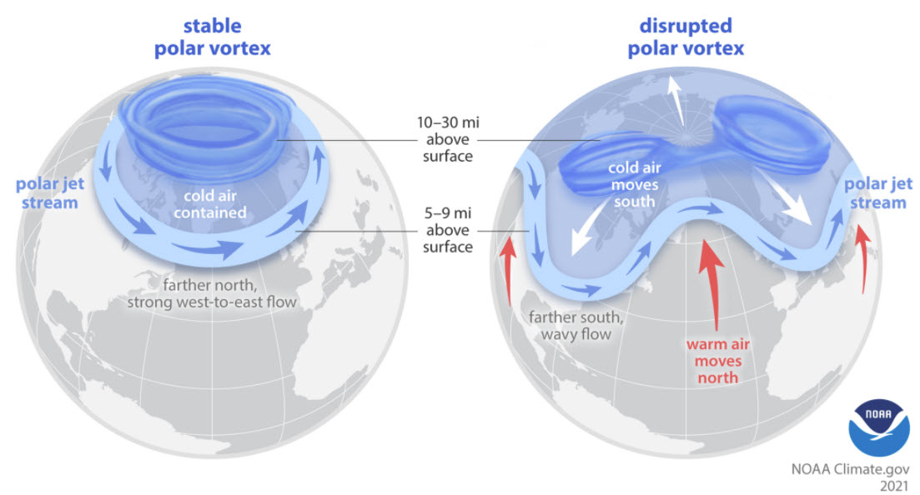[25]

The Arctic polar vortex creates the polar jet stream, and sets it in motion around the north pole. A stronger vortex pulls the jet stream north and keeps it stable. When the vortex weakens, as it has in recent years, the jet stream is allowed to travel farther south, bringing cold dry air to interact with the warm wet equatorial air. These are not small polar vortices. These are loops and undulations in the jet stream that can cause hurricanes, cold snaps, and adverse weather events around the globe.

In NERC’s view, understanding these finer details of meteorology may not seem important. But as the institution that addresses safety and reliability standards for much of North America’s energy system, it is critical that they understand the challenges the future holds.

For their part, the inquiry team did identify temperature and natural gas supply chain issues as playing central roles in precipitating the crisis, and further identified the interdependencies between the electric and natural gas systems.

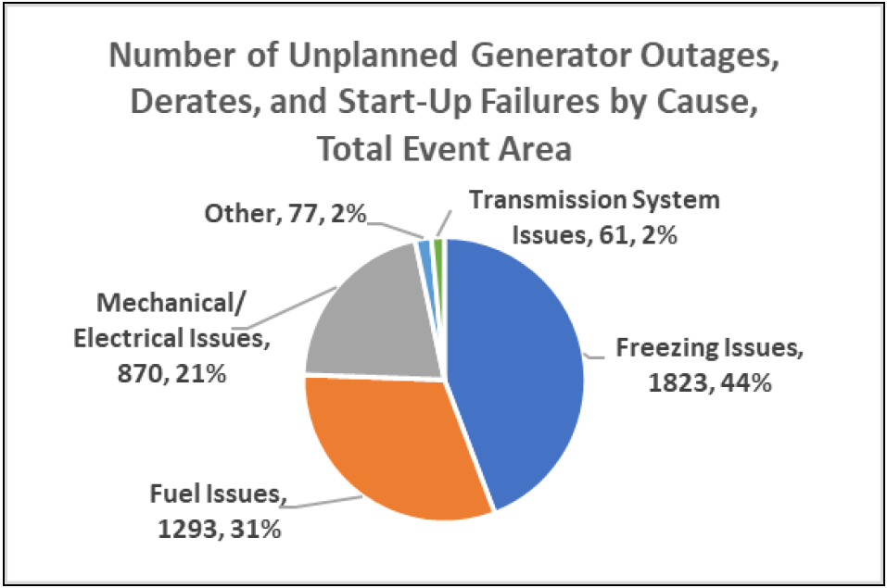[26]

Their report identified 44% of unplanned outages, derates, and startup failures as being caused by freezing. They further contended that an “analysis of the 21% of outages, derates or failures to start caused by ‘Mechanical/Electrical Issues’ indicated that they are also related to the cold temperatures.”[27] The report also suggested that almost a third of outages were due to fuel issues.[28]

However, these figures are effectively meaningless because they are reported as the “Number of Unplanned Generator Outages, Derates, and Start-up Failures”, and total up to 4,124 occurrences. This is many times the number of generating units in Texas, and still doesn’t represent those generators that did not suffer an outage. This is because one generator unit can come on and offline multiple times, and each one is recorded as an outage.

This emphasis on the role of freezing temperatures in precipitating the emergency may well be exaggerated. First, our earlier analysis indicated that the strength of the relationships between temperatures and generation outages was lower than any other relationship we considered. Secondly, the inquiry staff is using questionable data for statistical analysis. Thirdly, the inquiry staff did not consider the possibility of voluntary shutdowns.

As mentioned earlier, the $9000/MWh electricity price provides an incentive to prolong crises, as higher rates of generation failure promise larger returns for those resource entities with multiple generating units. To be sure, in a competitive market, any price above expected costs would provide an incentive to generate, and the prospect of large profits would ensure that the generators were prepared for cold weather.

However, in an oligopolistic market, generators may receive larger profits by colluding to manufacture and prolong crises, as was done in California 20 years ago. Given the real risk of such practices, the inquiry staff would have done well to scrutinize the self-reporting of generators.

A similar lack of critical investigation was apparent in the inquiry staff’s discussion of natural gas curtailments. Cold weather was obviously a factor determining declines in natural gas production, and we confirmed that temperature Granger caused a reduction in natural gas production. But there may be more to the story.

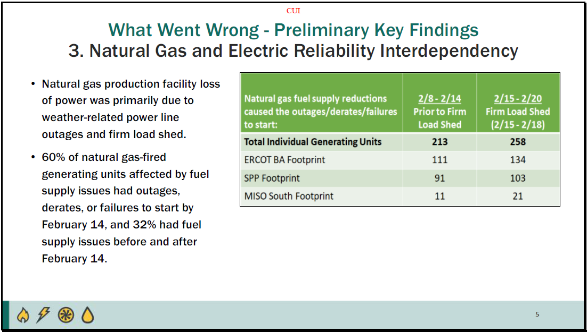[29]

Our review of causal structure presented above found the impact of temperature on natural gas production declines to be relatively weak. Moreover, blackouts were determined to be Granger causal of natural gas production declines, as well as natural gas generation outages. That temperature is such a poor determinant of natural gas production suggests that the issue of voluntary curtailment of natural gas production should be investigated.

Also, the ability of blackouts to explain variation in natural gas generation and production suggests that failures to adequately manage the dependency of the two systems may be more consequential than is noted in the inquiry staff’s report.

Our review of causal structure presented above identified a mismatch between the crisis at the start of February 15, 2021 and the period immediately following. Natural gas production decreased before the rolling blackouts and the rolling blackouts were ordered before the increase in plant outages.

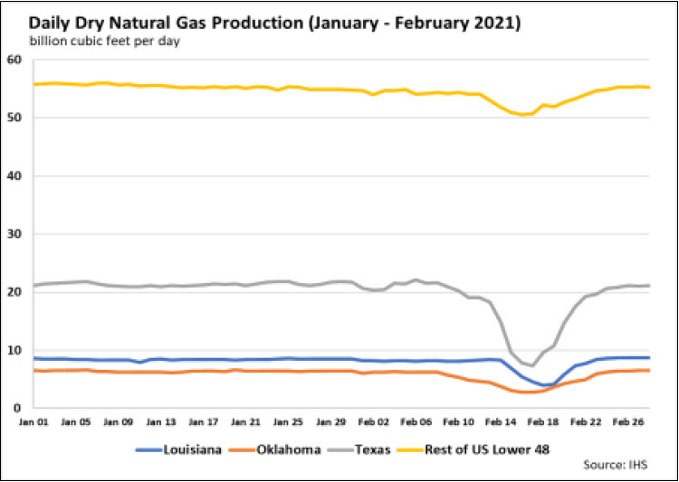[30]

This is significant because Energy Transfer Partners and Kinder Morgan collectively reaped over $3.4 billion in additional profits during the course of the emergency.[31],[32] Basic economic theory tells us that a market as concentrated as that of natural gas is susceptible to the use of voluntary curtailment as a means of increasing profit margins. With two of Texas’ largest natural gas producers receiving enormous windfalls from the event, the possibility of market manipulation should be investigated.

The Texas Railroad Commission has recently faced criticism over their regulation of natural gas.[33] Unfortunately, the inquiry staff did not identify market structure as one of the potential factors influencing declines in production, nor did they carefully review the impacts of natural gas transportation in February.

A very significant part of their presentation focused on issues with Under Frequency Load Shedding (UFLS). Both generating stations and customers facilities are designed to operate at a specific range of frequencies. Operating at frequencies different than design can cause significant damage. For that reason, equipment is designed to cease operating when the frequency falls below a specific value.

The image below is slide 13 in the NERC presentation. It describes how, due to the UFLS designations of certain circuits, system operators were constrained in how they could allocate available load shedding, a major tool in the system operators’ tool kit for addressing frequency deviations.

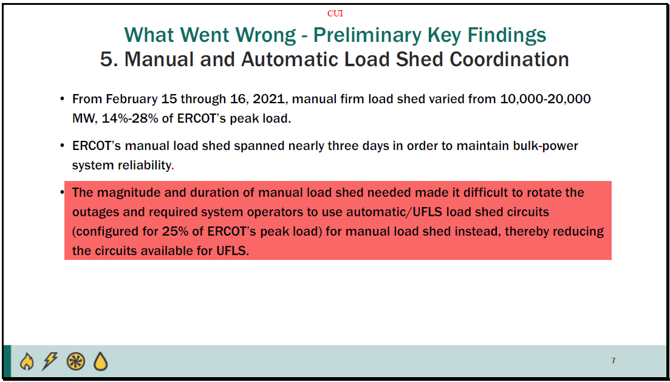[34]

The highlighted passage on slide 13 also suggests that the transmission authorities were having to use their last line of defense (the underfrequency circuits) to manage frequency during the emergency.

The limited information currently available makes it unclear whether the underfrequency load shedding took place or not. The testimony by ONCOR’s CEO before the Texas Senate Committee on Business & Commerce on February 26, 2021 indicated that the customer side of automatic frequency load shedding might have been invoked.[35] When referring to the need for instantaneous automatic triggering UFLS, Nye had stated “the situation gets that dire, and it did”, implying the automatic relays had been needed in this case. This is odd because he also stated that the grid hovered just two thousandths of a Hz above the automatic trigger point of 59.3Hz, nearly enacting their “last safety blanket”, but not quite.

The University of Texas study of the February event indicates that the use of automatic UFLS was minimal and, perhaps, accidental, but certainly could happen above an observed 59.302Hz in one part of a vast and interconnected system:

"Confidential responses of TDSPs to ERCOT requests for information note UFLS relay tolerances of +/- 0.01 Hz, and some TDSPs recorded frequencies between 59.300 and 59.310 Hz during the critical frequency period indicated in Figure 2.j. As reported by five of the major TDSPs in ERCOT, the total MW UFLS by automatic (by experiencing low frequency) triggering of relays was on the order of 200 MW for 2 to 3 dozen circuits.

In addition to automated triggering of UFLS relays, the TDSPs also included some circuits with UFLS relays in the so-called manual load shed in which they selected circuits to trip offline to meet their portion of the load shed obligation as commanded by ERCOT. There were over 1000 circuits (possibly more than 2000) with UFLS relays included in this manual load shed. Thus, the manual load shed affected two orders of magnitude more load, number of circuits, and customers than were triggered via automated UFLS. At all times the TDSPs were still required to have 25% of load on circuits with UFLS relays."[36]

Both the ERCOT and the NERC/FERC review have been relatively silent on the dramatic decline in frequency over the 15-minute period starting at 1:45 A.M. on February 15, 2021.

The next image is possibly the most important slide in their presentation. The graphic on this slide, most frequently in ERCOT hearings and in the press, is the chart of frequency deviations and rolling blackout orders:

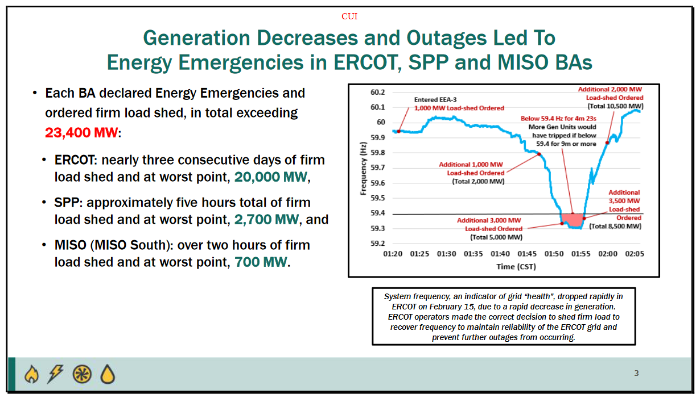[37]

Oncor president’s testimony at the Texas Senate appears inconsistent with the slide above – especially since he repeatedly cited the beginning of a frequency issue as 2:02 A.M. This is roughly 40 minutes after than the first 1,000 MW of manual load shedding was ordered under EEA-3 alert by ERCOT. In this chart this is nearly the point when the frequency returned to a more normal operating range.

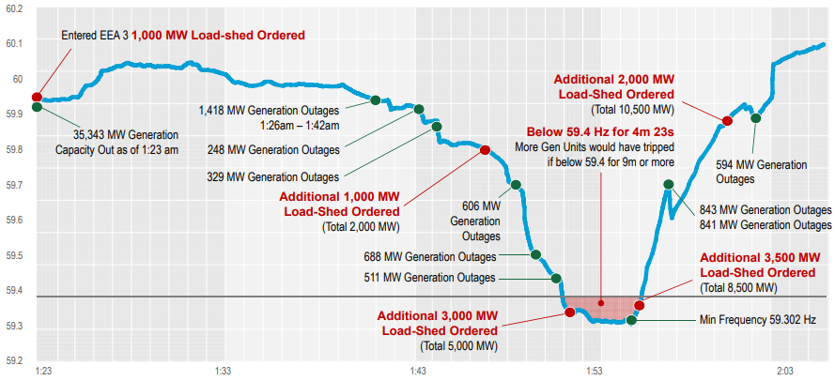[38]

The chart above is a more comprehensive version of the ERCOT frequency chart than that presented in the NERC/FERC presentation. It is taken from an official ERCOT Presentation; the *Review of February 2021 Extreme Cold Weather Event.[39]* It shows that during the period of critically low frequency, generation continued to trip offline. As Mr. Nye himself stated, the only way to keep the frequency up while supply is dropping is to shed load.

In ERCOT, a manual load shed is not implemented by the ERCOT control center. Instead, the order is communicated to ERCOT’s transmission providers. These, in turn, communicate the order to local distribution centers who have thirty minutes to implement the order. Surprisingly, much of the Texas system appears to rely on antiquated methods requiring the dispatch of a line truck to the substation to be taken off-line.

There is a sense of ERCOT being a vast ocean liner responding very slowly to an oncoming ice berg. Ordering measures that take thirty minutes to implement is a very poor approach to a frequency problem whose duration was only fifteen minutes.

ERCOT’s internal reports for this period would seem to indicate that the management of rolling blackouts and UFLS was in disarray:

“Feb. 15th

01:09 – VDI deploying Groups 1 and 2

01:11 – XML deploying Groups 1 and 2

01:49 – Frequency drops below 59.7Hz

60 MW of obligated, undeployed LRs trip off

02:05 – XML hourly XML to all resources sustaining deployment

02:09:48 – XML recalling most LRs

02:16:12 – XML recalling the remaining LRs

Both recall instructions due to miscommunication within ERCOT Control Room”[40],[41]

Overall, the NERC/FERC report appears to have minimized the complexity of ERCOT’s problems on the morning of February 15th.

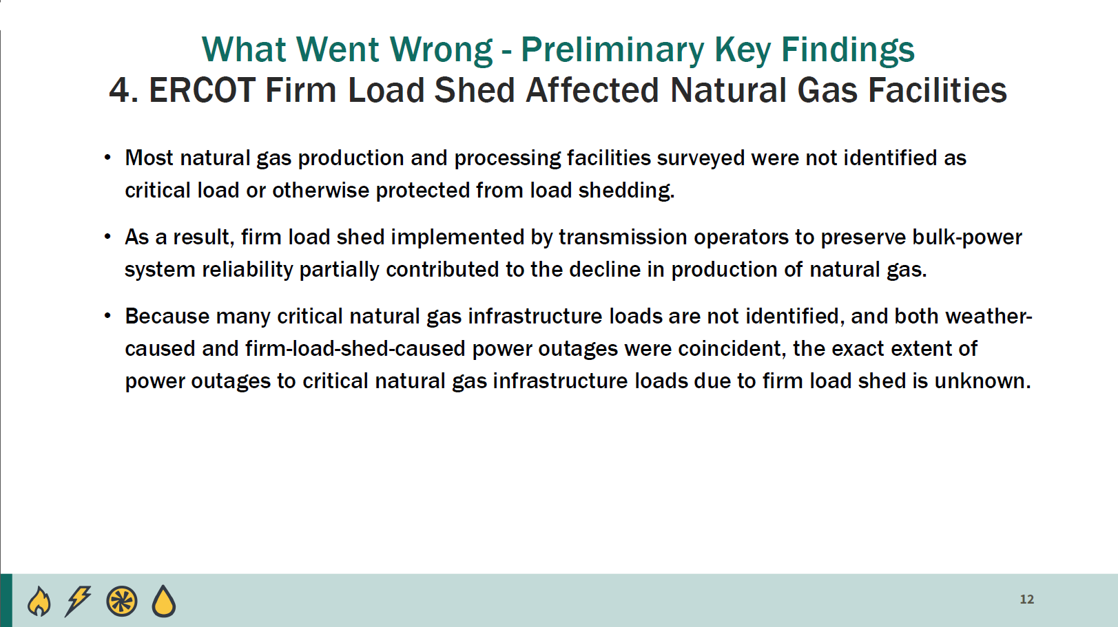[42]

Owing to what one author has termed “a convenient crisis of identity”, ERCOT has been able to maintain a chimeric identity as a quasi-governmental organization (which may be granted sovereign immunity from liability), and a private organization (which is not subject to the Texas Public Information Act).[43],[44] This convenient crisis of identity has allowed ERCOT to keep many crucial documents out of public view.

ERCOT has yet to release any disaggregated figures for February’s generation outages by outage type; they have not publicly posted the results from their weatherization spot-checks (2011-present); they have not published the list of critical natural gas participants who failed to apply for critical infrastructure status; and they have justified withholding all of this information on the basis that it ensures the protection of competitively sensitive information.[45],[46] In short, ERCOT—who has recently been ruled as not being subject to the Texas Public Information Act—supports their secrecy via the obscure claim that the opacity of their market actually decreases the likelihood of manipulation.[47]

FERC’s mission — to provide “Economically Efficient, Safe, Reliable, and Secure Energy for Consumers.” — is put in jeopardy by the possibility of manipulation.[48] Yet, the report by FERC and NERC staff did not address the lack of transparency in ERCOT operations.

As mentioned earlier, the inquiry staff did not subject the structure, opacity, or incentives systems extant in the ERCOT market to any critical investigation. The staff did make engineering recommendations for what they appeared to have viewed as an engineering problem.

To anyone who grew up in the heady days of the Public Utilities Regulatory Policies Act (PURPA) the nine key recommendations are simply common sense and have long been adopted in other jurisdictions.[49]

The key recommendations are:

1. Generators to identify, address (or retrofit), train, and plan for cold weather.
2. Generators should be compensated to meet cold weather requirements.
3. Congress and regulators should require the natural gas industry to address cold weather.
4. The natural gas industry should also prepare for cold weather.
5. FERC should encourage a forum where the involved parties to meet together to address information sharing, regulatory authority, and state actions.
6. Participants should identify reliability risks in natural gas contracts.
7. FERC should host a technical conference on this issue.
8. Generators should inspect their equipment before cold weather.
9. Planners should adjust their calculations for cold weather.

These are not bad recommendations. However, these issues are generally addressed by utility planners and contract negotiators on an ongoing basis. The questions that need to be asked are:

1. Why were these very commonsense measures not already in place?
2. Why will their implementation take so long?

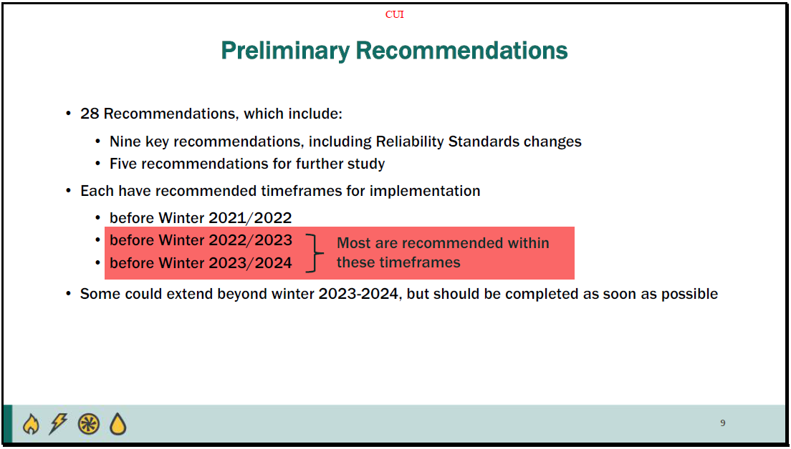[50]

Given that many of these recommendations are past due, we may have expected a sense of urgency in their implementation; however, in many cases, market participants are only asked to research and deliberate over issues of vital concern, and those recommendations which do call for tangible alterations do so over extremely lenient time frames.

Changes in our climate have precipitated multiple reliability failures this year. Without drastic action we may expect similar failures to repeat themselves. Yet, with winter rapidly approaching, the inquiry staff has still recommended that the lion share of its recommendations be implemented before winter 2022/2023 or by winter 2023/2024, and even suggested that some may be completed later. Moreover, the inquiry staff shies away from recommending any enforcement mechanisms.

Take for instance the recommendations for weatherizing generating units. The inquiry staff suggested that generator operators would be required to prepare for specific ambient temperatures; however, “generator owners that experience outages…due to freezing” are only required to “review the generating unit’s outage…develop and implement a corrective action plan…and evaluate whether the plan applies to…other generating units.”[51]

Similarly, the inquiry staff called on balancing authorities and transmission operators to include “processes for identifying and protecting critical natural gas infrastructure” in their “provisions for operator-controlled manual load shed.”[52]

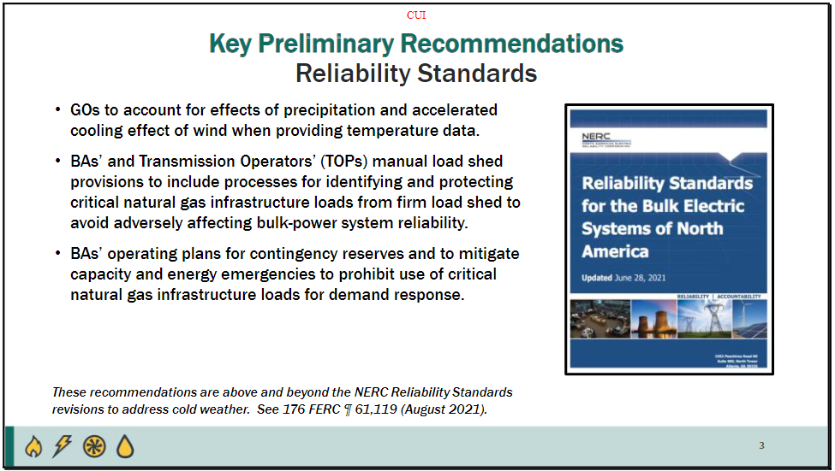[53]

Although NERC/FERC identified the same causes for natural gas curtailments in their 2011 report on the Southwest Cold Weather Event, ERCOT and local regulators did not effectively implement NERC’s recommendations.[54] Merely requiring balancing authorities to initiate processes for protecting critical infrastructure will not ensure that such processes are followed – especially when follow-through on these requirements has been problematic.

ERCOT already hosts a Gas Electric Working Group, where stakeholders can “engage in open dialog…[and] discuss topics,” with one another.[55] Such deliberations did not maintain natural gas supplies in February. A requirement that BAs and TDSPs begin developing similar processes *under no threat of penalty* is seems unlikely to guarantee fuel supplies in the future.

In brief, the preliminary NERC/FERC analysis is inadequate, and its recommendations are likely to be ineffectual and severely delayed. The report made many observations on weatherization, greater interconnection, and protection of critical infrastructure. However, all of these were suggested during the 2011 crisis, but were not heeded as there was no consequence for ignoring NERC’s recommendations.

In our changing world, we can expect an increasing number of extreme weather events. We can expect generation equipment to operate more or less to its factory specifications. But, if we continue to view crises such as the one in February as extreme weather causing generators to fail, rather than as human beings failing to keep generators operating, we can expect similar results in the future.

The inquiry staff said nothing of the incentive systems which may impede or facilitate certain behaviors and outcomes. They said nothing of ERCOT’s peculiar energy-only market and the perverse incentives it creates. Nor did they mention the concentration or opacity of the ERCOT market.

The inquiry team seemed to express a perspective which viewed the February crises as merely an engineering problem and a “black swan.” This entirely ignores the set of institutional arrangements which incentivize poor performance, shield malefactors from accountability, and which, if left unaltered, may likely produce equally devastating results in the future.

1. 2021 Summer Reliability Assessment, North American Electric Reliability Corporation, May 2021, pg. 5.
2. During the summer of 2021, this required de-energization of one of the two major interconnections – luckily not on days when the California ISO faced capacity limitations.
3. Reliability Standards for the Bulk Electric System of North America, NERC, June 28, 2021.
4. 2020 Long-Term Reliability Assessment, North American Electric Reliability Corporation, December 2020, pg. 46.
5. Hurricanes Hanna, Isaias, Laura, Sally, Delta, Zeta and Tropical Storm Eta.
6. 2020 Long-Term Reliability Assessment, North American Electric Reliability Corporation, December 2020, pg. 36.
7. https://www.ferc.gov/media/february-2021-cold-weather-grid-operations-preliminary-findings-and-recommendations-full
8. February 2021 Cold Weather Grid Operations: Preliminary Findings and Recommendations,

   FERC, NERC and Regional Entity Joint Staff Inquiry, September 22, 2021, pg 15.
9. Regulatory Questions Engendered by the Texas Energy Crisis of 2021, Dr. Carl Pechman and Elliott J. Nethercutt, March 5, 2021, pg. 1.
10. https://www.visualcrossing.com/
11. Winter Storm Uri - Natural Gas Analysis, ENVERUS, Prepared for: Texas Oil and Gas Association (TXOGA), April 2021, pg. 25.
12. http://www.ercot.com/news/february2021
13. http://www.ercot.com/content/wcm/lists/226521/51878_ERCOT_Letter_re_Preliminary_Report_on_Outage_Causes.pdf
14. February 2021 Cold Weather Grid Operations: Preliminary Findings and Recommendations - Full Presentation, pg. 4.
15. Investigating causal relations by econometric models and cross-spectral methods. C.W. Granger, Econometrica 37, 424-438.
16. All regressions referenced above used the first difference of the underlying data to address autocorrelation.
17. https://www.texastribune.org/2021/02/16/natural-gas-power-storm/
18. http://www.ercot.com/content/wcm/lists/226521/51878_ERCOT_Letter_re_Preliminary_Report_on_Outage_Causes.pdf
19. The question was “Was there any sort of adjustment for the reduced expected capacity that wind and solar produce, seeing as they are considered an "intermittent" resource?” and the response was “ERCOT’s April 6 preliminary report made no adjustment for the intermittent nature of solar and wind resources. That report used only the installed capacity as a measure of the MW unavailable due to reported outages and derates. In ERCOT’s April 27 update to the preliminary report, it provided additional information showing outage and derate MW values based on expected MW that would have been available from solar and wind but for the outages.”

    http://www.ercot.com/content/wcm/lists/226521/ERCOT_Responses_to_Preliminary_Outage_

    Report_Questions.pdf
20. February 2021 Cold Weather Grid Operations: Preliminary Findings and Recommendations,

    FERC, NERC and Regional Entity Joint Staff Inquiry, September 22, 2021, pg. 5.
21. https://www.texastribune.org/2021/02/17/abbott-republicans-green-energy/
22. February 2021 Cold Weather Grid Operations: Preliminary Findings and Recommendations - Full Presentation with commentary, pg. 4.
23. 2021 Summer Reliability Assessment, North American Electric Reliability Corporation, May 2021, pg. 4.
24. https://cpo.noaa.gov/Meet-the-Divisions/Communication-Education-and-Engagement/CEE-News/ArtMID/8293/ArticleID/2369/Research-Links-Extreme-Cold-Weather-in-the-United-States-to-Arctic-Warming
25. https://www.climate.gov/news-features/understanding-climate/understanding-arctic-polar-vortex
26. February 2021 Cold Weather Grid Operations: Preliminary Findings and Recommendations,

    FERC, NERC and Regional Entity Joint Staff Inquiry, September 22, 2021, pg. 5.
27. February 2021 Cold Weather Grid Operations: Preliminary Findings and Recommendations, FERC, NERC and Regional Entity Joint Staff Inquiry, September 22, 2021, pg. 8.
28. Note that this slide depicts aggregated totals for all three balancing authorities in Texas; MISO, ERCOT, and SPP
29. February 2021 Cold Weather Grid Operations: Preliminary Findings and Recommendations,

    FERC, NERC and Regional Entity Joint Staff Inquiry, September 22, 2021, pg. 5.
30. February 2021 Cold Weather Grid Operations: Preliminary Findings and Recommendations,

    FERC, NERC and Regional Entity Joint Staff Inquiry, September 22, 2021, pg. 4.
31. https://www.wsj.com/articles/energy-transfer-reaps-2-4-billion-windfall-from-texas-freeze-11620340520#:~:text=Energy%20Transfer%20ET%203.38%25%20LP,stemming%20from%20the%20February%20storm.
32. https://www.bloomberg.com/news/articles/2021-04-21/kinder-morgan-posts-blowout-earnings-on-gains-from-texas-freeze#:~:text=Kinder%20Morgan%20Inc.,call%20with%20investors%20on%20Wednesday.
33. Especially when the chair of the Rail Road Commission, who is charged with regulating the natural gas industry, has been identified as having significant equity in the natural gas sector but has not recused herself from cases where this has been determined to be a conflict of interest (https://commissionshift.org/wp-content/uploads/2021/09/Commission-Shift-Captive-Agency-Part-I.pdf).
34. February 2021 Cold Weather Grid Operations: Preliminary Findings and Recommendations,

    FERC, NERC and Regional Entity Joint Staff Inquiry, September 22, 2021, pg. 7.
35. https://tlcsenate.granicus.com/MediaPlayer.php?clip_id=15395.
36. The Timeline and Events of the February 2021 Texas Electric Grid Blackouts, University of Texas, July 21, page 40.
37. February 2021 Cold Weather Grid Operations: Preliminary Findings and Recommendations,

    FERC, NERC and Regional Entity Joint Staff Inquiry, September 22, 2021, pg. 6.
38. http://www.ercot.com/content/wcm/key_documents_lists/225373/2.2_REVISED_ERCOT_Presentation.pdf
39. Review of February 2021 Extreme Cold Weather Event – ERCOT Presentation, Bill Magness, February 24, 2021, slide 12.
40. ERCOT Winter Storm Review of Demand-Side Resources and Other Related Topics, ERCOT Staff, April 16, 2021, slide 10.
41. VDI means “voice dispatch instruction” – more usually referred to as a telephone. XML means “extensible markup language” – more usually referred to as email, text, or other electronic communication.
42. February 2021 Cold Weather Grid Operations: Preliminary Findings and Recommendations,

    FERC, NERC and Regional Entity Joint Staff Inquiry, September 22, 2021, pg. 12.
43. https://sanantonioreport.org/ercot-convenient-identity-crisis/
44. The Attorney General of Texas Ken Paxton has ruled that ERCOT is not subject to The Public Information Act (<https://www.dallasnews.com/business/energy/2021/06/23/attorney-general-ken-paxton-rules-ercot-not-subject-to-texas-public-information-act/>), and The Texas Supreme Court evaded their last opportunity to decide if ERCOT could be sued (<https://www.statesman.com/story/news/2021/03/19/texas-supreme-court-declines-say-if-ercot-can-be-sued/4764392001/>)
45. McCullough Research staff requested a breakdown of generation outages by type. Although such information is available—as is evident in ERCOT’s unplanned resource outage reports for the summer of 2021 (https://sa.ercot.com/misapp/GetReports.do?reportTypeId=20466)—ERCOT responded that that “spreadsheet contains data that in some cases could be used to determine the cause of outages for specific generation units and that information is confidential. See ERCOT Protocols section 1.3.1.1(1)(m).” (Email addressed to McCullough Research staff).
46. Many ERCOT TDSPs were also contacted regarded changes in their critical infrastructure filing lists. Although Oncor’s CEO testified in front of the Texas capital that their list had grown from 35 to 168 natural gas facilities during the event, neither Oncor nor any other TDSP responded to McCullough Research’s requests (https://dfw.cbslocal.com/2021/02/26/texas-capitol-hearing-oncor-ceo-outages/).
47. See footnote 44, above.
48. https://www.ferc.gov/what-ferc
49. PURPA dictated rules where independent power could “put” their projects to utilities. Acquisition rules of PURPA resources included detailed reliability standards such as those recommended in September’s report.
50. February 2021 Cold Weather Grid Operations: Preliminary Findings and Recommendations,

    FERC, NERC and Regional Entity Joint Staff Inquiry, September 22, 2021, pg. 9.
51. February 2021 Cold Weather Grid Operations: Preliminary Findings and Recommendations,

    FERC, NERC and Regional Entity Joint Staff Inquiry, September 22, 2021, pg. 1.
52. February 2021 Cold Weather Grid Operations: Preliminary Findings and Recommendations - Full Presentation, pg. 20.
53. February 2021 Cold Weather Grid Operations: Preliminary Findings and Recommendations, FERC, NERC and Regional Entity Joint Staff Inquiry, September 22, 2021, pg. 3.
54. https://www.ferc.gov/sites/default/files/2020-04/08-16-11-report.pdf
55. http://www.ercot.com/committees/other