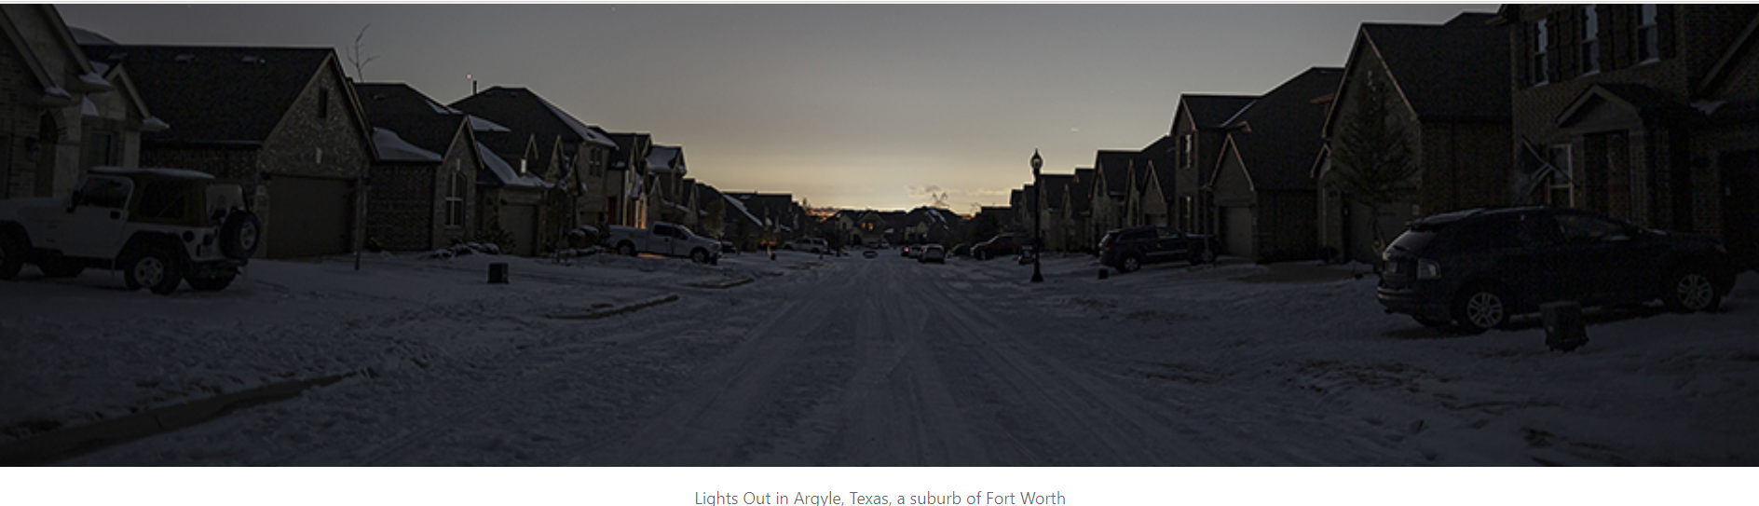 Chris Rusanowsky/ZUMAPRESS/Newscom

**ERCOT Reliability:** **Systematic Unpreparedness**

**A Twentieth Century Solution for a Twenty-First Century Problem**

**Larry Kellerman and Robert McCullough**

The unfortunate state of the ERCOT power system can be summarized in two words: systematic unpreparedness. The origins of this disaster included the lowest reserve margins in North America, ignoring basic maxims of preparing for bad winter weather, and a market design that rewards shortages at the cost of consumers.

The North American Electric Reliability Corporation (NERC) was tasked by the 2005 Energy Policy Act to address America’s electric reliability issues. Their most recent report shows that ERCOT – the Electric Reliability Committee of Texas – has the lowest level of reserves of any area in North America:

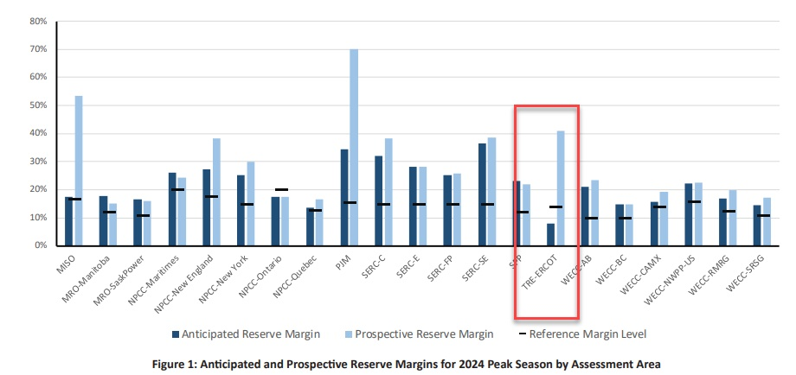[1]

At a reserve margin of only 7.8%, NERC summarized the situation in Texas as only “marginal”:

[2]

The NERC summary clearly identifies Texas as being the least prepared area across three North American countries to meet a harsh winter.

Unfortunately, the level of systematic unpreparedness is not only reflected in the lack of capacity to meet consumers’ needs. Even the engineering issues of meeting cold weather requirements has been woefully inadequate.

The report from the Public Utilities Commission of Texas (PUCT) clearly identifies a core root cause for the winter rolling blackouts and a conventional set of recommendations not requiring particularly large deployments of either capital or technological expertise:

"The winter freeze greatly strained the ability of the Texas electric utilities to provide reliable power to their customers. Record and near-record low temperatures were felt throughout the state resulting in a significantly increased demand for electrical power. At the same time that demand was increasing, weather-related equipment malfunctions were causing generating units to trip off the line. As a result, the state suffered widespread rolling blackouts and near loss of the entire ERCOT electric grid.”

"The extreme weather pointed out several weak areas in power plant operations. Inoperative or inadequate heat tracing systems and inadequate insulation on instrumentation sensing lines seemed to be the most common technical equipment problem encountered during the freeze."[3]

While the above quote from a PUCT report appears to be ripped from today's headlines, the report was issued in 1990 and relates to a then-record freeze and the resulting rolling blackouts initiated by ERCOT during winter weather event that hit Texas from December 21 to December 23, 1989. While the causes of the February 2021 ERCOT-wide systemic reliability failures are varied and multi-dimensional, it is clear as of this point that the dominant cause of the rolling blackouts was the tens of thousands of megawatts of freeze-related forced outages that struck ERCOT's thermal generation fleet. Those who point to ERCOT's increasing reliance on wind generation and the icing issues that have plagued a number of wind turbines throughout the region fail to appreciate that Texas wind generation only contributes on average a modest minority of the power supply during the lower wind winter months, and that by ERCOT's own records, actual wind production on February 15 was almost unchanged from the days immediately prior to the unseasonably cold weather.

The PUCT report on the 1989 outage was spot-on with respect to what needed to be done, and provided affirmative recommendations for rectifying the situation prospectively. These were positive recommendations, but they were not regulations that the then-regulated ERCOT integrated electric utilities were required to follow. While capital improvements to certain power generation facilities were made in a number of cases, the problem of insufficient freeze protection at the region's power plants and at the fuel supply infrastructure supporting and feeding these plants persisted, and were exacerbated by the deregulation of ERCOT's generation two decades ago and the development of new generation plants unfettered by historic regulatory oversight. And December 1989 wasn't the region's only, or for that matter, most recent experience with systemic winter-related generation outages resulting in loss of load.

Stepping back ten years from the present, in February 2011, a significant cold snap hit Texas and, once again, thermal generation units without comprehensive heat tracing, insulation of critical freeze-prone assets and other protective measures cascaded into forced outage conditions just when they were most critical to grid reliability. Rolling outages were required to stabilize the grid. This time, the legislature took notice and in June 2011 passed a bill designed to address the root cause identified for the prior winter's reliability failure entitled "A Report by the Public Utility Commission of Texas on the Ability of Electric Generators to Respond to Abnormal Weather Conditions" (Texas-2011-SB1133). That legislation, now on the books for a decade, in part reads:

"The commission (ie, PUCT) shall analyze emergency operations plans developed by electric utilities, power generation companies, municipally owned utilities, and electric cooperatives that operate generation facilities in this state and prepare a weather emergency preparedness report on power generation weatherization preparedness. In preparing the report, the commission shall:

* review the emergency operations plans currently on file with the commission;
* analyze and determine the ability of the electric grid to withstand extreme weather events in the upcoming year;
* consider the anticipated weather patterns for the upcoming year as forecasted by the National Weather Service or any similar state or national agency; and
* make recommendations on improving emergency operations plans and procedures in order to ensure the continuity of electric service."[4]

Thus, for the past decade, every year there are "plans" submitted by generators to the PUCT, and the PUCT prepares reports that are filed with the legislature. These plans and reports have clearly not, in and of themselves, moved the needle in terms of addressing the underlying root cause issue for winter season generation failures that have resulted in multiple instances of highly disruptive, societally highly expensive rolling blackouts in Texas. One of the two original co-sponsors of this bill, Glenn Hegar, who transitioned from the Texas State Senate to the role of Texas Comptroller of Public Accounts, noted in regard to the February 2021 blackout event, "we must address why, after 10 years have passed (since his 2011 legislation), are we in a worse position today than in 2011."

ERCOT and the PUCT knew the key technology fixes required for assuring optimal winter reliability in 1989, as well as in 2011 and today. The technology that must be robustly and comprehensively deployed across ERCOT's generation fleet is relatively old tech, 20th century tech, including heat tracing, insulation and metrology. This is tech that can save us multiple billions of dollars of excess cost and societally devastating loss of load in the next inevitable winter weather event.

But the Texas power market's need to look to the past for a 20th century technology solution is overshadowed by its need of a structural solution from the 20th century that the PUCT and ERCOT seem to have forgotten that they retain in their arsenal of tools. And that 20th century tool is good old-fashioned regulation. We have regulators who, as in the response to the 1989 winter outage event, make suggestions. They were good suggestions. We have legislators who, as in the response to the 2011 winter outage event, legislate that the regulators write reports. That was fine enough legislation and the resulting reports out of the PUCT were good reports. But an immodest suggestion is simply for the Texas regulators to regulate, to dictate unconditionally that if you want to participate in the often lucrative, free-market tilting ERCOT power market, you must adhere to certain minimum facility freeze protection standards and that your grid-connected generation facilities must meet minimum standards with respect to unusually low temperature ambient conditions.

The ERCOT marketplace has, for better or worse, been overseen by regulators who have preferred to incentivize reliability outcomes with market-based structures and economic carrots over more traditional regulation of utilities. The dictionary definition of regulation is "a rule or directive made and maintained by an authority". This definition may seem a bit outmoded in the free market leaning ERCOT ecosystem, but regulation is precisely what has been missing, or at minimum, overly light and permissive in assuring energy security when Texans need it the most. The mission-critical arena of winter season reliability is too societally important to be governed by Adam Smith's "invisible hand" of the market, and an artificially constructed and imperfect marketplace at that.

The theory implemented by the Texas Public Utilities Commission assumes that skyrocketing prices during system emergencies will create incentives to correct shortages and blackouts. All evidence is that this does not work. Regulatory requirements for safety are almost universal in our economy. These apply to road, sea, and air transport, manufacturing, environmental protection, and worker safety. Elsewhere in the U.S., electric systems that do not protect the public, or consistently fail, would lead to sanctions. In Texas, regulators have called for even higher penalties to be borne by consumers.

As Newsweek reported:

“In the emergency order, the PUC explained that ERCOT had informed them that energy prices across the system were clearing at less than the current system-wide offer cap of $9,000. The caps ensure customers are protecting from massive price hikes.

“At various times on Monday, emergency prices across the system were clearing as low as approximately $1,200.

The commission said it believes this is inconsistent with the fundamental design of the ERCOT market.” [5]

The exact wording in the emergency order is:

"ERCOT has informed the Commission that energy prices across the system are clearing at less than $9,000, which is the current system-wide offer cap pursuant to 16 TAC § 25.505(g)(6)(B). At various times today, energy prices across the system have been as low as approximately $1,200. The Commission believes this outcome is inconsistent with the fundamental design of the ERCOT market. Energy prices should reflect scarcity of the supply. If customer load is being shed, scarcity is at its maximum, and the market price for the energy needed to serve that load should also be at its highest.”[6]

The theory that expanding the crisis by mandating even higher prices is simply poor economics. The widespread blackouts show that mandating high prices during emergencies has not created an incentive to build enough generation, make sure that it is operational during extreme weather, or served consumers adequately.

In short, regulators need to regulate all of ERCOT's generation market participants, those who supply both thermal and renewable power, and those who form critical components of their fuel supply and operational supply chains, to assure that in return for the privilege - not the inherent right - to participate in ERCOT's power marketplace, participants are mandated to implement tried-and-true, conventional capital additions and operational programs necessary to assure operational integrity during inclement weather. A 20th century solution for what should no longer be a 21st century problem.

*Larry Kellerman is Managing Director of I Squared Capital* (this article represents the personal opinion of the writers and does not necessarily reflect the views of I Squared Capital.)

*Robert McCullough is principal of McCullough Research in Portland, Ore., and advises governments, utilities and Aboriginal groups from California to Quebec on energy issues*

1. 2019 Long-Term Reliability Assessment, NERC, December 17, 2019, page 11.
2. Ibid., page 12.
3. “Electric Utility Response to the Winter Freeze of December 21 to December 23, 1989”
4. https://legiscan.com/TX/bill/SB1133/2011
5. https://www.newsweek.com/texas-utility-commission-orders-energy-price-hikes-1569554
6. Second Order Directing ERCOT to Take Action and Granting Exception to Commission Rules, Texas Public Utilities Commission, February 16, 2021, page 1.