Date: September 21, 2026

To: McCullough Research Clients

From: Robert McCullough Marty Howard
Jean-Carl Ende Joshua Crawford
William Clouse Michael Weisdorf

Subject: Reviewing the NECEC Litigation Filings

On September 8, 2026, both parties to the New England Clean Energy Connect (NECEC) agreements filed complaints in federal court. The complaints concern Hydro-Quebec’s interruption of deliveries of energy to Massachusetts during the first two months of the twenty-year length of the NECEC Agreement.

While the contract amounts are large, comprising 1,090 MWh/hour – approximately equivalent to the output of a nuclear plant – the dispute in the complaints is basically a debate over “netting” damages from the U.S. buyers’ payments to Hydro-Quebec.

Of more interest is the viability of the Agreement in light of global warming, Hydro-Quebec’s precarious load resource balance, and the simmering trade war with the United States.

Summary:

The NECEC entered commercial operations on January 16th. Nine days later, on January 25th, Hydro-Quebec interrupted deliveries. In January and February, Hydro-Quebec interrupted flows thirteen times.

In principle, the NECEC commits to the delivery of 1,090 MWh/Hour for twenty years at a fixed price. The energy must be provided by sixty-two Quebec hydroelectric projects with a nameplate capacity of 38,767 MW. As we will see below, the majority of these projects are already committed to Quebec’s customers under the 2000 Act respecting the Régie de l’Energie and other legislative provisions.

The poorly drafted NECEC contract bears much of the blame. In the winter of 2025/2026, Hydro-Quebec faced very limited capacity reserves and was entering the fourth year of an extreme drought.

If Hydro-Quebec were a car, it would be driving down a rocky road without a spare and the fuel tank nearly empty.

The NECEC contract is incomplete. Important terms are undefined, priority of deliveries are not addressed, and Hydro-Quebec’s interruption process lacks important details.

Hydro-Quebec’s sales literature uses phrases like “inexhaustible” and “in abundance.”

Under normal conditions this is relatively true. However, in the fourth year of a deep drought, hydro-electricity is neither inexhaustible nor abundant. Hydro-Quebec’s own filings at the Regie de l’Energie show a very different picture:

By the end of winter this year, Hydro-Quebec’s reservoirs were at the second lowest level in twenty years.

When reservoir levels are low, potential energy diminishes, and, at the same time, environmental and engineering issues must be addressed. The technical term for these constraints is “critical rule curve” – the operating limits that restrict further releases of water until the reservoirs begin to refill in the spring and summer.

Hydro-Quebec’s capacity situation was no better. Hydro-Quebec’s capacity balance is reported through the Northeast Power Coordinating Council (NPCC). Their winter 2025/2026 report was issued on December 1st, 2025. It provided the authoritative statement of Hydro-Quebec’s load/resource balance:

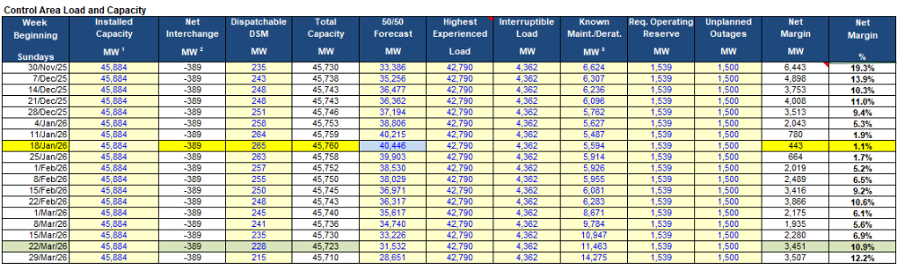
The line highlighted in yellow forecasts the tightest net reserve margin as the week of the 18th of January – the same week when the interruptions on the NECEC began.

This is the week when net reserves were forecasted to fall to 1.1%. Almost any setback, cold weather, equipment failure, or an Act of God could topple Quebec into rolling blackouts.

While the NECEC contract is a large block of energy, it should be noted that the NECEC is not addressed in the reliability assessment:

The New England Clean Energy Connect (NECEC), a new 1,200 MW, tie line connecting Québec to Lewiston, Maine will be commercialized (in late 2025). An energy-only contract into Maine/New England has been signed. Energy-only contracts are not modeled in this study.

This statement is at the heart of the current litigation. The concept of an “energy-only contract” was apparently unfamiliar to the drafters of the NECEC contracts. The terms of delivery were inadequately described and left operationally undefined. Elsewhere in North America there are a wide variety of contract models – especially in hydro-electric dominated regions. This is not the case in New England.

Similar contracts elsewhere specifically address priority of service. A contract should specifically address which entity gets how many megawatt-hours when supplies are limited. As a matter of law, most utilities are required to serve their own firm customers first. Interruptible customers – usually large industrials receive second priority. Off-system firm contracts are third in line and non-firm contracts are last.

The NPCC seasonal assessment does address the contract between Ontario and Quebec to exchange summer and winter capacity. Ontario supplies 600 MW of capacity to Quebec in the winter and receives 600 MW of Quebec capacity in the summer. This agreement is modeled in the NPCC winter assessment.

The NECEC contract does not address an energy only transaction largely because Quebec supplies are inexhaustible and in abundance. Even the Massachusetts Supreme Court in the NextEra decision was silent on what would happen if a drought or a capacity shortage blocked delivery.,

The omission of contract language designed to handle allocation of energy during a drought is a major error and basically the cause of the current litigation.

Although the emergency declaration that TransEnergie issued has not been provided to their customers, it is a necessary procedural step in any interruption of service. Hydro-Quebec’s complaint is not convincing on the nature of the emergency that took place.

Their argument is that TransEnergie declared a force majeure in January, but does not go into details about the nature of the event. The most significant information in their complaint is the passage concerning the seven days of cold weather:

Prior to the force majeure event, there had never been a period in which Québec peak load equaled or exceeded 38,000 megawatt-hours (“MWh”) for seven consecutive days.

Focusing on a sequence of high loads is irrelevant in terms of capacity reserves, but is very relevant for continued draws on already low reservoirs – especially in midwinter.

It is logical to assume that there was an emergency – loads were high, reservoirs were low, and Hydro-Quebec was importing thermal from other regions. However, it has provided no evidence of the actual emergency declaration or even reports to the Regie, the Northeast Power Coordinating Council (NPCC) or the North American Electric Corporation (NERC).

The actual emergency declaration is a critical omission in Hydro-Quebec’s complaint.

The NECEC contract itself is unusual in its use of undefined terms: language like “such as” to define specific events and “likely” in the determination of specific data. All of these unusual contract elements add to the risk of future litigation.

Background:

Hydro-Quebec is a crown corporation – owned and operated as a branch of the government of Quebec. Unlike most U.S. utilities, its finances and policies are set by the ruling party. There is a regulatory agency in Quebec, but it is also a branch of the government of Quebec. In practice, both in terms of regulation and transparency, Hydro-Quebec is a unique institution.

When Francois Legault became premier of Quebec in 2018 and appointed his long-term friend, Pierre Fitzgibbon, as “super-minister” of industry and energy, the objectives became exports and low rates. The two objectives were not easily reconciled. Delays in the exports to New England (NECEC) and New York (CHPE) did not bring in the needed revenues. Simultaneously, load growth continued without substantial new energy supplies to meet them.

Hydro-Quebec’s utility planning documentation is scarce – often just a few pages. Detailed operating and financial data are equally hard to come by. Ironically, Quebec’s interest in selling into U.S. markets has made much ordinary data from Quebec only available in the U.S. -- at the Federal Energy Regulatory Commission (FERC), the North American Electric Reliability Corporation (NERC), the Security and Exchange Commission (SEC), and the neighboring control areas in Ontario, New York, and New England.

The lack of published information in Quebec tended to make it difficult to understand that Quebec was rapidly running out of both capacity and energy over the past decade. In March of 2022, the 2022-2026 Strategic Plan of just forty-six pages summarized the approaching crisis – reaching load/resource balance by 2026 in capacity and 2027 in energy. The plan would require C$25 billion in new investment by 2026.

The following year, the 2035 Action Plan made it painfully obvious that Quebec was reaching crisis levels in just a few years. It proposed meeting additional needs by 2035 of 60 TWh and 8,000 to 9,000 MW by 2035 at an additional cost of C$200 billion.

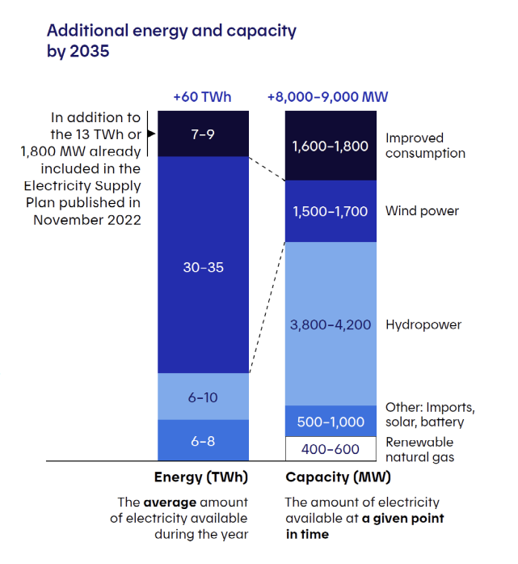
The most authoritative source for Quebec’s level of reliability is, not surprisingly, the December 2025 Reliability Assessment for Winter 2025-2026 from the Northeast Power Coordinating Council (NPCC).

The NPCC’s forecast for the winter of 2025/2026 indicates a very low net reserve margin for Quebec:
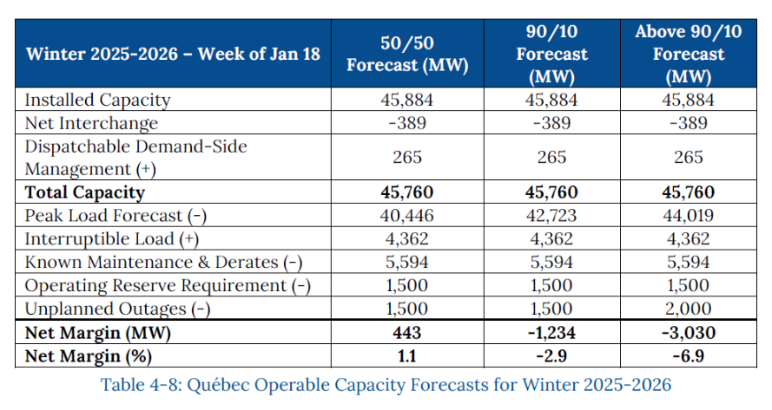
The NPCC forecast indicates that Quebec would fail to meet their reserve requirement at loads above 41,520 MW in the week of January 18, 2026. At this point, the 1,090 MWh/hour commitment to New England requires 1,090 MW of actual capacity to generate the electricity to be delivered – especially since the NECEC contract specifies the source of the energy must come from the sixty-two projects specified in Exhibit A.

The Hydro-Quebec complaint specifies that their load reached 40,747 MW on January 25, 2026. This places them above the expected peak load forecast. With the generation required to meet the NECEC commitment from Quebec hydroelectric projects, this would bring their net margin below zero.

Alternatively, the emergency could have been on the transmission system within Quebec. However, this would contradict a clear statement in the 2025/2026 NPCC winter assessment. The NPCC states that Hydro-Quebec has a transmission design criterion that should protect the system up to a load of 44,446 MW:

90/10 load weather and 90/10 temperatures

90/10 and above 90/10 cold weather results in a large load pickup over the 50/50 demand forecast. This situation is addressed at the planning stage through Hydro-Québec’s Transmission Design Criteria. When designing the system, one particular criterion requires that both steady state and stability assessments be made with winter scenarios involving demands 4,000 MW higher than the normal weather peak demand forecast. This is equivalent to 110% of normal peak winter demand. This ensures that the system is designed to carry the resulting transfers while conforming to all design criteria. Resources needed to serve the load during such episodes must be planned and provided by Hydro-Québec, the Load Serving Entity.,

The NPCC study was surprisingly prescient – forecasting the lowest net reserve margins during the same weeks as the dates discussed in the two complaints:

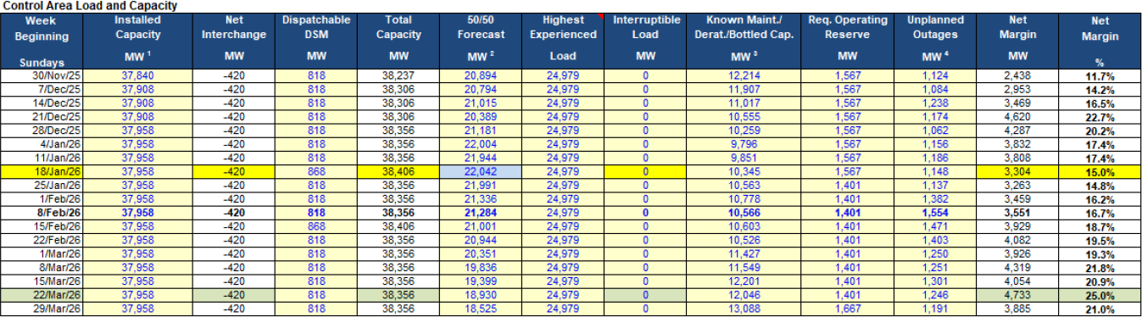

Neither complaint addresses the exact operating data from the period under discussion – a curious lapse for discussions that are now in their seventh month. However, the NPCC forecasts indicate that Hydro-Quebec faced a capacity deficiency in the period being litigated.

And the 2022 through 2026 Strategic Plan clearly could not have addressed the energy shortfalls that occurred the year after its publication. As stated earlier, Hydro-Quebec has been in the midst of a very serious drought since 2023.

Hydro-Quebec’s first quarter financial report is quite explicit about the impact of reservoir levels and low runoffs on utility operations:

Context of the first quarter

The results for the first quarter of 2026 are set against a backdrop of the low runoff conditions observed over the last three years. Natural water inflows during this period have been lower than normal overall, due in particular to decreased precipitation and spring runoff, resulting in historically low levels in large reservoirs. The company’s financial performance also reflects a context characterized by periods of intense cold, particularly at the end of January, when peak demand in Québec exceeded 38,000 MW for seven consecutive days, a historic high. Temperatures were an average of 9°C colder than climate normals during this period. These conditions impacted the management of energy reserves. They resulted in a decrease of 1.0 TWh in sales outside Québec as well as in an increase in electricity purchases during a period when prices are usually high. It should also be noted that the security of Québec’s energy supply was never compromised.

Financially, the impact of the continued drought was quite significant in the first quarter with the cost of energy purchases at C$1,539 million and revenues from exports at only C$526 million.

In terms of megawatt-hours, net exports have declined precipitously since previous years:

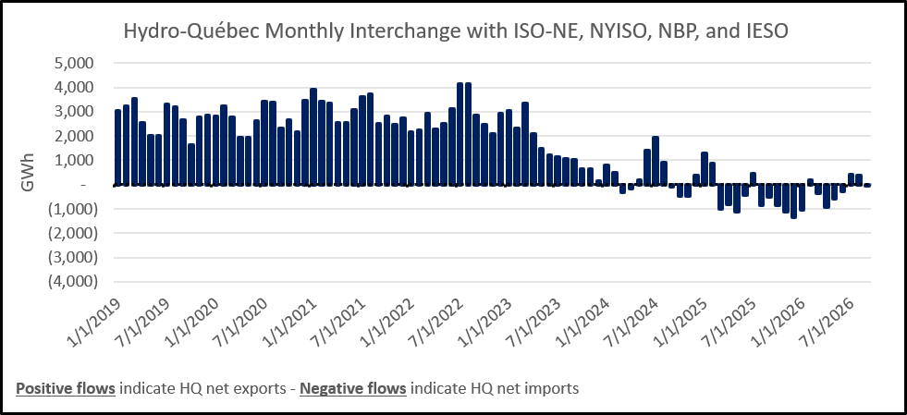

The net imports from ISO-NE, NYISO, NBP, and IESO in the first quarter were 3.4 TWh.

Reviewing the Contract Language:

The complaints by both Hydro-Quebec and the Massachusetts utilities are interesting in many ways. First, while they dwell in some detail on a short period in January and February, interruptions of the NECEC have continued throughout 2026:

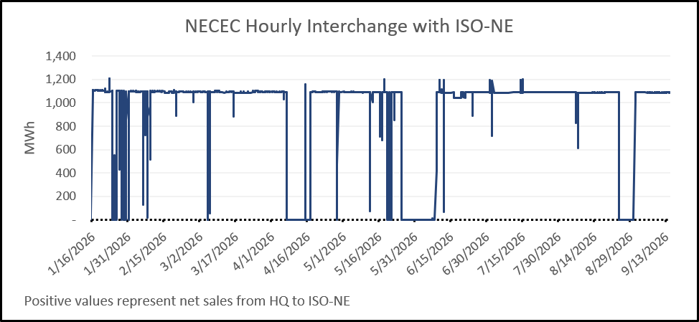

The central debate concerns a standard part of all energy contracts – force majeure. The term is from the Code Napoleon of 1804 and roughly means “things outside of the parties’ control.” Contract clause 10.1 spends three pages inadequately explaining the term. The first sentence is convoluted enough to cause legitimate disagreements:

10.1 Force Majeure.

(a) The term “Force Majeure” shall mean
(i) an event:
(A) that was not within the control of the Party claiming its occurrence;
(B) that could not have been prevented or avoided by such Party through the exercise of reasonable diligence; and
(C) that directly prohibits or prevents such Party from performing its obligations under this Agreement,
(ii) an Excused Outage,
(iii) any failure by Seller to satisfy any of its obligations to Deliver any of the Products or any portion of the Products that is caused by or arises from a Force Majeure under the TSA that is not caused, in whole or in part, by any act or omission by Seller or any of its Affiliates and that directly prohibits or prevents Seller from performing its obligations under this Agreement, or
(iv) a Reliability Curtailment that is not caused, in whole or in part, by any act or omission by Seller or any of its Affiliates and that directly prohibits or prevents Seller from performing its obligations under this Agreement.

Any sentence that runs to 175 words is problematic. However, this section is inadequate since listing the things outside the parties’ control is simply good practice. In this case, the second unduly long sentence lists the things force majeure is not – apparently with a number of minor typographic errors:

Under no circumstances shall Force Majeure include

(t) a change in Law or accounting standards or rules or a change in the interpretation or applicability thereof under Section 19.7(a),
(u) an Adverse Determination,
(v) any full or partial curtailment in the electric output of the Hydro-Québec Power Resources or in the operation of the Québec Line, in each case, that is caused by or arises from a mechanical or equipment breakdown or other mishap or events or conditions attributable to normal wear and tear or flaws at the Hydro-Québec Power Resources or the Québec Line, unless such curtailment or mishap is caused by one of the following: acts of God such as floods, hurricanes or tornados, or other significantly unusual and abnormal weather conditions such as severe blizzards or severe ice storms; sabotage; terrorism; or war,
(w) any occurrence or event that merely increases the costs or causes an economic hardship to a Party, including due to changes in market conditions,
(x) any occurrence or event that was caused by or contributed to by the Party claiming the Force Majeure,
(y) Seller’s ability to sell the Qualified Clean Energy or Qualified Shortfall Energy or associated Environmental Attributes at a price greater than that set out in this Agreement, or
(z) Buyer’s ability to procure the Qualified Clean Energy at a price lower than that set out in this Agreement.

Unfortunately, these 224 words don’t address what a force majeure is – only what it is not. Notably, section (v) lists “mechanical or equipment breakdown from normal wear and tear” as something that does not qualify as a force majeure event, except if that physical breakdown was caused by “acts of God such as floods, hurricanes or tornados, or other significantly unusual and abnormal weather conditions such as severe blizzards or severe ice storms.”

So, the final list of force majeure events includes floods, hurricanes, tornados, severe blizzards, and severe ice storms, but only if they caused a mechanical breakdown which resulted in the full or partial curtailment of electric output of the Hydro-Québec Power Resources, or in the operation of the Québec Line.

This contract language is confusing and imprecise. An exception to an exception is, in effect, a double negative. The phrase “such as” invites debate since reasonable people can easily disagree what this means in practice. And again, “severe blizzards” is not a term used in climate science or even everyday meteorology. Are “severe blizzards” a term we would normally use for describing a seven day “cold snap”? Generally, this is not the case in everyday communication.

Although the typographic errors in this section are not serious, they are unusual in a contract of this importance. The misspelling of “tornadoes” and the subsection numbering starting at “t” and extending through “z” leaves open the question where subsections “a” to “s” are.

Both complaints tiptoe around the imprecision in the force majeure language.

The reference to the “Quebec Line” requires some effort to track down. This turns out to be the portion of the HVDC line from the Quebec DC converter station to the U.S. boarder

Fundamentally, there is no evidence that there were problems on the Quebec Line during this period. The focus on weather is doubtful since the weather during this period was not unusual. Most importantly, terms like “severe blizzard” are undefined in the contract.

Although Hydro-Quebec did not invoke Section 4.2(a) of the NECEC contract, it also contains unusual contract language:

Notwithstanding any other provision of this Agreement, if during the Services Term, the LMP at the Delivery Point is negative, or, in the reasonable opinion of Seller, is likely to become negative, then Seller may deliver to Buyer a written notice stating that such condition has occurred or is likely to occur and the period during which such condition has occurred or is likely to occur. Buyer and Seller hereby agree that in such event Seller shall be under no obligation to schedule or transfer Deliveries of Qualified Clean Energy to the Delivery Point during such period. Seller shall provide Buyer with detailed information, including but not limited to, the start and stop times of such periods of curtailment under this Section 4.2(a) as well as the quantity curtailed, for all such periods of non-delivery during the preceding calendar month, which information shall be provided prior to Seller’s delivery of the invoice to Buyer.

It appears to commit the Massachusetts utilities to accept Hydro-Quebec’s estimate that the LMPs will likely be negative at some point in the future.

In its complaint, Hydro-Quebec references the regulations set by the Regie and NERC:

An extreme, prolonged, and life-threatening cold weather event gripped much of North America from January to February 2026, including New England and Québec. As a result of that event and its aftermath, TransÉnergie—the electrical grid operator for Québec, which operates under the umbrella of Hydro-Québec Canada (Hydro-Québec US’s parent company)—instituted emergency reliability curtailments to protect the safety and reliability of the grid. TransÉnergie’s issuance of reliability curtailments is governed by reliability standards developed by the North American Electric Reliability Corporation and adopted by Québec’s energy regulator, the Régie de l’énergie. TransÉnergie’s emergency reliability curtailments required Hydro-Québec US to partially or entirely limit the delivery of energy to the Distributors at various points in time between January 24, 2026, and February 9, 2026.

Hydro-Quebec’s attention to such rules is challenging to verify.

In December, 2025 Hydro-Quebec apparently issued two level two emergency declarations on the 3rd and the 5th. The declarations were informal. The emergencies were only revealed after press inquiries were made of Hydro-Quebec and reported in the press on December 9, 2025.

Hydro-Quebec’s lack of transparency in January and February is consistent with previous practice – unusual for the industry – but not unusual for Hydro-Quebec.

A major deficiency in the NECEC contract is a lack of specification for the term “prompt.” Normally a contract would specify the length of time under discussion – an hour, a day, a week, or a month might all be prompt in different circumstances. In electricity, however, events take place very quickly – five minutes, for example is a common time horizon in operational discussions.

In the complaint by the Hydro-Quebec’s customers, they note the delays in Hydro-Quebec communications. In contrast, NERC’s EOP-004-4 – Event Reporting policy cites twenty-four hours or end of the business day. Clearly, this was not the standard used in January 2026.

Finally, the question has been asked whether the poor performance of the NECEC and its companion line to New York, the CHPE, represents a political response to Donald Trump’s pointless trade war against the largest U.S. trading partner.

Michael Sabia, then CEO of Hydro-Quebec, and currently, Premier Carney’s Clerk of the Privy Council and Secretary to the Cabinet, addressed this on January 14, 2025:

"It's not something we could use immediately because it's basically power delivery in the future. We have looked at our options in the past... Is it a good thing under the circumstances to tear up an agreement with all kinds of legal and legal consequences for Hydro-Québec? [...] For me, it's still an open question."

Given the frequent flow of imports from the United States, this would be a self-defeating policy in the short run. Quebec needs the United States more than the United States needs Quebec now that Hydro-Quebec is in the grip of a fourth year of drought.

With the 2026/2027 cold weather rapidly approaching, this would be a very bad time to break off energy trade relations with the U.S.

The current interruptions in both New England and New York are more likely energy and capacity limitations than an ineffective boycott of freeing exports,

Conclusions:

- The most likely explanation for the system emergency is a shortage of capacity and energy on the Hydro-Quebec system. Hydro-Quebec’s repeated references to a seven-day sequence of cold weather days clearly represents a sequence of high drawdown days from already depleted reservoirs.
- Hydro-Quebec’s reticence concerning system emergency declarations has been seen before – in fact as recently as December 2025.
- The NECEC contract is poorly written:
  - There is no priority of service language in the contract. The Massachusetts customers are entitled to an explanation why their loads and not others were interrupted.
  - Many of the terms are undefined and the use of phrases like “such as” is clearly ambiguous.
  - Some critical passages leave the seller in complete control of the outcome – especially Section 4.2(a) where Hydro-Quebec can simply assume the likelihood of negative prices at the ISO NE delivery point and cease delivery.
  - The long and poorly constructed sentences concerning force majeure defy interpretation.
  - Typographic errors in the same section are probably not significant, but it is logical to ask whether the missing subsections (a) through (s) in the second sentence of 10.1(a) actually existed and were removed, or, more likely, never existed.
  - The ownership of hydro-electric generation in the contract is confusing at best and misleading at worst. Almost all hydro-electric generation is reserved during winter months for Quebec’s existing customers. If so, how can thousands of megawatt-hours in the NECEC and CHPE actually come from the same resources?
- Hydro-Quebec is approaching next winter with low reservoirs and limited capacity. It would make little sense for Hydro-Quebec to interrupt cross border energy trade when they will be needing help this winter.
- Both parties to the NECEC would benefit from clarification of the existing contract terms.

Netting is a common term in energy agreements and simply involves reducing the amount the customer pays to the supplier by amounts owed by the supplier to the customer. Given that credit support for Hydro-Quebec is the Province of Quebec, this would appear to be more about frustration than the need for security.
https://www.publicationsduquebec.gouv.qc.ca/fileadmin/Fichiers_client/lois_et_reglements/LoisAnnuelles/en/2000/2000C22A.PDF
Hydropower | Advantages | Hydro-Québec and FAQ.
annexea-etat-des-reserves-et-fiabilite-energetique-au31aout2026
Reliability Assessment for Winter 2025-2026 Final Report, NPCC, December 1st, 2025, page 65.
Ibid., page 18.
In our review, we were only able to find one similar transaction in New England: the 2010 contract between a consortium of twenty small Vermont utilities and Hydro-Quebec. The Vermont Public Service Board approved the contract on March 15, 2011. While similar, it is much smaller, which is a critical difference when priority of service issues are considered.
Reliability Assessment for Winter 2025-2026 Final Report, NPCC, December 1st, 2025, page 20.
https://law.justia.com/cases/massachusetts/supreme-court/volumes/485/485mass595.html
Energy only products still require capacity for delivery – the energy must actually be generated to be delivered to customers.
H.Q. Energy Services U.S., Inc., Plaintiff, V. Nstar Electric Company (D/B/A Eversource Energy), Fitchburg Gas and Electric Company (D/B/A Unitil), Massachusetts Electric Company and Nantucket Electric Company (D/B/A National Grid), page13.
The NPCC is the organization responsible for reliability in eastern Canada, New York and New England. NERC is the organization with overall responsibility for reliability for most of North America.
2022-2026 Strategic Plan, Hydro-Quebec, March 2022, page 9.
Ibid., page 12.
Action Plan 2035 – Towards a Decarbonized and Prosperous Québec, Hydro-Quebec, November 2023, page 21.
Ibid., page 26.
Reliability Assessment for Winter 2025-2026, Northeast Power Coordinating Council, Inc., December 1, 2025.
Ibid., page 22. Minor typographic errors were corrected in the Operating Reserve Requirement row and the Net Margin (MW) and Net Margin (%) values for the 50/50 Forecast (MW) column.
H.Q. Energy Services U.S., Inc., Nstar Electric Company (D/B/A Eversource Energy), Fitchburg Gas and Electric Company (D/B/A Unitil), Massachusetts Electric Company and Nantucket Electric Company (d/b/a National Grid), page 13.
Ibid., page 49. Emphasis supplied.
40,446 MW + 4,000 MW = 44,446 MW.
Ibid., page 65.
Hydro-Québec | Quarterly Bulletin | Q1-2026, page 2.
Ibid., pages 18 and 19.
McCullough Research tabulations from https://www.eia.gov/electricity/gridmonitor/dashboard/electric_overview/US48/US48, https://www.iso-ne.com/isoexpress/web/reports/grid/-/tree/real-time-actual-five-minute-scheduled-interchange, https://mis.nyiso.com/public/P-32list.htm, https://energy-information.canada.ca/en/resources/high-frequency-electricity-data, Index of /public/IntertieScheduleFlowYear
Ibid.
https://www.iso-ne.com/isoexpress/web/reports/grid/-/tree/real-time-actual-five-minute-scheduled-interchange
Power Purchase Agreement for Firm Qualified Clean Energy from Hydroelectric Generation Between Nstar Electric Company D/B/A Eversource Energy and H.Q. Energy Services (U.S.) Inc. as of June 13, 2018, page 47.
Ibid., pages 47 and 48.
This sentence uses letters to delineate the different items not defined as force majeure events starting with “t” and proceeding through “z”. It is up to the reader to assume this is a typographic error or that “a” through “s” were omitted by mistake.
Attachment A, Page A-1 in Transmission Service Agreement by and Between Central Maine Power Company, as Owner, and Massachusetts Electric Company and Nantucket Electric Company D/B/A National Grid, Collectively as Distribution Company.pdf
Tabulations from https://www.iso-ne.com/isoexpress/web/reports/grid/-/tree/real-time-actual-five-minute-scheduled-interchange https://climate.weather.gc.ca/historical_data/search_historic_data_e.html
Power Purchase Agreement for Firm Qualified Clean Energy from Hydroelectric Generation Between Fitchburg Gas and Electric Light Company D/B/A Unitil and H.Q. Energy Services (U.S.) Inc. as of June 13, 2018, Exhibit A, Page 24. (emphasis added)
H.Q. Energy Services U.S., Inc., Plaintiff, V. Nstar Electric Company (D/B/A Eversource Energy), Fitchburg Gas and Electric Company (D/B/A Unitil), Massachusetts Electric Company and Nantucket Electric Company (D/B/A National Grid), September 8, 2026, Page 2. Emphasis supplied.
How an early cold snap pushed Hydro-Québec's power grid to its limit | CBC News
eop-004-4.pdf
Should electricity contracts with the Americans be reviewed? Money, January 14, 2025.

