Date: March 3, 2022

To: McCullough Research Clients

From: Robert McCullough

Subject: Adding an Excise Tax on Russian Oil Exports

The war in Ukraine makes it very tempting to take steps to reduce Russia’s revenues from oil – their major export. However, most discussions of this issue have missed a critical point. The objective is to reduce Russia’s revenues – not cause a shortage of oil that could impact many U.S. allies. And, also important, Putin’s war has increased Russia’s revenues as potential risks have driven the price of its crude exports to the highest levels we have seen in years.

There have been proposals to boycott or embargo Russian oil. Both policies – either using good will or military force – have significant downsides.

The U.S. is the world’s leading oil producer. The second largest producer is a close U.S. ally. Russia is the third largest oil producer. The U.S. does relatively little business in Russian oil – either importing crude or exporting refined products. However, the U.S. through its market presence has enormous influence over oil markets.

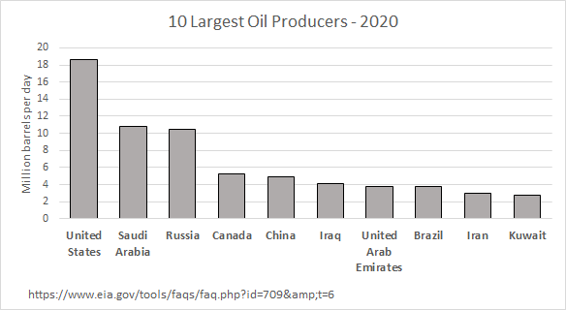

The BBC has estimated that oil contributes 60% of Russia’s exports and 39% of Russia’s federal budget.[1] Oil revenues are a critical area of leverage on Putin’s policies – probably vastly more visceral than the seizure of the jets and villas of Russian oligarchs.

While a boycott and embargo on Russian crude are tempting, they pose significant downsides:

1. Since the oil market is a single worldwide marketplace, a successful boycott or embargo might cause higher prices and shortages to U.S. allies;
2. Boycotts are difficult to manage and enforce; and,
3. Embargos face the risk of armed conflict.

Boycotts are often unsuccessful since they may place a hardship on the purchaser. An embargo, especially an embargo backed by military force, poses significant risks when the target has an unstable leader and a nuclear arsenal.

Most importantly, they may not be needed.

An excise tax, on the other hand, is easy to implement, would not change prices nor supplies, but will reduce Russia’s export revenues.

Implementation is straightforward. The U.S., Europe, the British Commonwealth, Japan, and other trading nations place an excise tax on Russian crude. The proceeds of the excise tax are spent on the emerging humanitarian crisis in Eastern Europe as hundreds of thousands – and possibly millions – flee the conflict in Ukraine.

The incidence of the tax is the key. Economists use this term to describe who actually pays the tax – the buyer or the seller. The key to the calculation is that the party with the alternatives avoids the tax, simply by buying elsewhere. In the case of oil, there are many alternative suppliers. The buyer can avoid the tax by picking up the phone and buying from the U.S. or Saudi Arabia. The opposite situation faces Russia, the seller. The world is not clamoring for their products, so they will have to accept a lower price than the market. As an economist, might say “the incidence of a Russian crude oil tax is entirely on the seller.”

Obviously, one of the largest customers might not choose to implement the tax – even if it is in their own interest. An option to add China to those implementing the tax would allow transportation costs to offset the tax. This would have little impact on Europe, but would reduce the tax to China which faces a far greater transportation challenge.

The excise tax is also easily graduated. An increase in the tax from 10% to 20% is simply an administrative act. If, as we expect, the Ukrainian conflict becomes increasingly violent, the excise tax can be adjusted to fund the humanitarian needs of those sheltering in Poland, Romania, and Hungary. Moreover, if Russia voluntarily withholds supplies, its revenues could still be reduced by changing the tax rate.

It is said that amateurs talk about tactics, but professionals study logistics.[2] History tells us that leverage on Putin is more likely to be from loss of revenue than weapons provided to the Ukrainians.

1. https://www.bbc.com/future/article/20211115-climate-change-can-russia-leave-fossil-fuels-behind
2. Gen. Robert H. Barrow, USMC (Commandant of the Marine Corps) in an interview published in the San Diego (CA) *Union* on November 11, 1979